

Duck-U-Up

Version #01

All work Copyright © 2016 by Harambe Interactive.

All rights reserved.

**Alexander Sikalevski**

Contents

Version History 3

Game Overview 4

Game Play Mechanics 4

Camera 4

Controls 4

Saving and loading 5

Interface Sketch 5

Menu and Screen Description 5

Characters 5

Non-player Characters 5

Enemies 5

Weapons 6

Items 6

Abilities 6

Vehicles 6

Script 6

Scoring 6

Sound Index 6

Story Index 6

Art / Multimedia Index 6

Design Notes 6

Future Features 6

# Version History

# Game Overview

Duck-U-Up is a twin-stick shooter. The player controls the duck which can shoot laser beams to destroy the enemy the red circles the universe most powerful enemies.

# Game Play Mechanics

# Camera

The camera will be scrolling from left to right and the player must stay in the cameras pov or else the player will be destroyed.

# Controls

The player can move the duck sprite using the W, A, S, and D keys to move in their respected directions. The player can also move using the arrow keys to move in their respected directions too. The player can use the mouse to aim the duck in a specific direction with precision. Finally the player can left click or press the space bar to shoot lasers in the direction the duck is facing.

# Saving and loading

# Interface Sketch

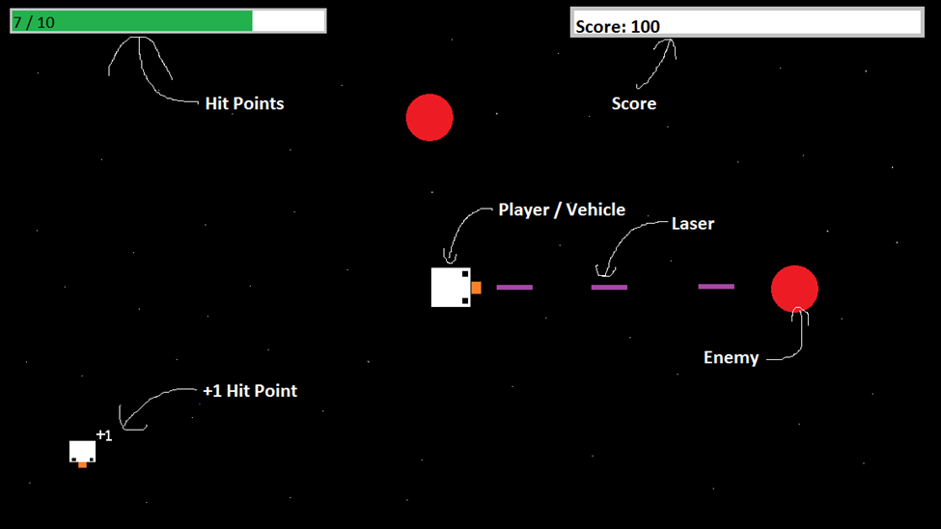

# Menu and Screen Description

# Characters

The player’s avatar is a duck.



# Non-player Characters

# Enemies

The main enemy in the game will be the red circles.



# Weapons

The players’ weapon will be the laser beam.  


# Items

The player can pick up the +1 duck power up which will give them +1 hp in game. If the player is at max hp the power up will not do anything.



# Abilities

# Vehicles

# Script

# Scoring

If the player destroys an enemy the player gains +10 points.

# Sound Index

# Story Index

# Art / Multimedia Index

# Design Notes

# Future Features